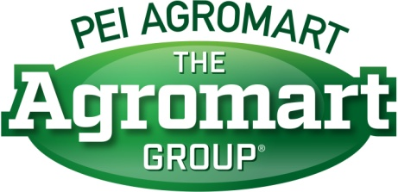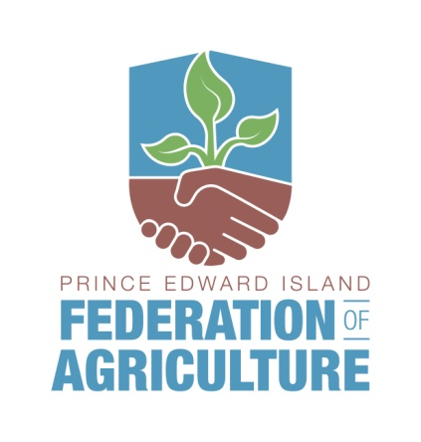
Scholarship Application Form
Application deadline is August 29, 2025

In Partnership with PEI Agromart and Island Lime, the PEI Federation of Agriculture is pleased to offer a scholarship of $2000 for the 2025/2026 academic year.
This scholarship is available to:
• PEI Federation members, their spouses or children who are enrolled in a post-secondary or graduate program or a leadership program that helps expand their knowledge of the industry
• Unsuccessful applicants may apply in subsequent years
• No applicant will be eligible for a second award
• The successful candidate will be asked to provide confirmation of enrolment
• Applicants will be screened and successful applicants will be selected for an interview

Applications will be evaluated on the following:
• A 250 word summary outlining:
- Farming Background
- Industry involvement
- Volunteer and Community Service
- Long term goals
• Two letters of endorsement.
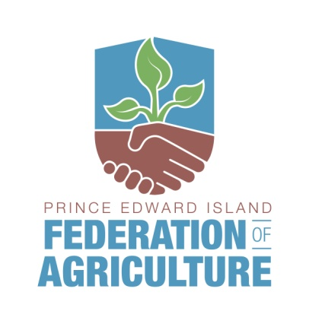
Agriculture Leadership Scholarship
presented by Prince Edward Island Federation of Agriculture,
Island Lime & PEI Agromart Ltd.

Application deadline is August 29, 2025
PEI Federation of Agriculture
100-159 Sherwood Road, Charlottetown PE C1E 0E5
Tel: 902-368-7289 Fax: 902-368-7204 Email: info@peifa.ca
(For fax or email, subject line should read “PEIFA Scholarship”)

Applicant’s name:
PEIFA Membership Farm Name:
Telephone: |  |  | Email:
Mailing Address:
Program of study:
Educational Institution
or Course Provider:
Period of study:

Please attach
- Two (2) letters of endorsement and a 250 word summary of:
- Farming background,
- Industry involvement,
- Volunteer & community service and
- Long-term goals hoped to be achieved through studies.

